Entities

🌟 Definition
# Source: AI Source: Provided by: [Data Path: Persons Table -> ID Column: 1, Name_En Column: Motasem Essam] -> From: [ChatGPT] on [6/10/2026]
An Entity is a real-world object, person, place, event, concept, or thing about which data is stored in a database.
Entities represent the major objects that a system needs to track and manage.

🎯 Purpose
# Source: AI Source: Provided by: [Data Path: Persons Table -> ID Column: 1, Name_En Column: Motasem Essam] -> From: [ChatGPT] on [6/10/2026]
Entities help answer:
- What information should the database store?
- What objects exist in the business domain?
- What things need to be tracked?

🧠 Simple Examples
# Source: AI Source: Provided by: [Data Path: Persons Table -> ID Column: 1, Name_En Column: Motasem Essam] -> From: [ChatGPT] on [6/10/2026]
Online Store
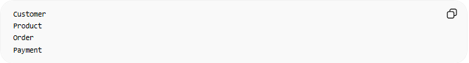
Entities:
Customer
Product
Order
Payment
School System
Entities:

Student
Teacher
Course
Classroom
Hospital System
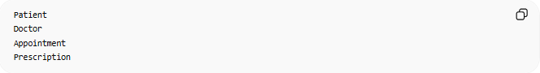
Entities:
Patient
Doctor
Appointment
Prescription

🔢 Characteristics of an Entity
# Source: AI Source: Provided by: [Data Path: Persons Table -> ID Column: 1, Name_En Column: Motasem Essam] -> From: [ChatGPT] on [6/10/2026]
An entity:
- Has a unique identity
- Has attributes (properties)
- Can participate in relationships
- Represents something meaningful to the business

📚 Entity Examples
# Source: AI Source: Provided by: [Data Path: Persons Table -> ID Column: 1, Name_En Column: Motasem Essam] -> From: [ChatGPT] on [6/10/2026]
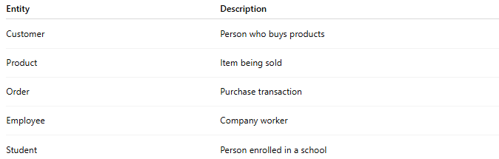
Entity | Description
Customer | Person who buys products
Product | Item being sold
Order | Purchase transaction
Employee | Company worker
Student | Person enrolled in a school

🗄️ Entity → Database Table
# Source: AI Source: Provided by: [Data Path: Persons Table -> ID Column: 1, Name_En Column: Motasem Essam] -> From: [ChatGPT] on [6/10/2026]
In relational databases, an entity usually becomes a table.
Entity
Customer
Database Table
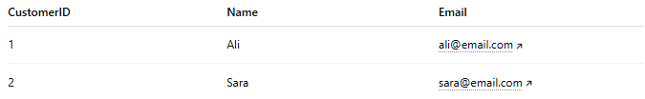
CustomerID | Name | Email
1 | Ali | ali@email.com
2 | Sara | sara@email.com
Here:
- Entity = Customer
- Table = Customers

🔗 Entity in an ER Diagram
# Source: AI Source: Provided by: [Data Path: Persons Table -> ID Column: 1, Name_En Column: Motasem Essam] -> From: [ChatGPT] on [6/10/2026]
Example:
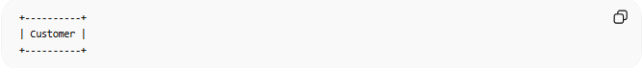
+----------+
| Customer |
+----------+
The rectangle represents an entity.

🌍 Real-World Example
# Source: AI Source: Provided by: [Data Path: Persons Table -> ID Column: 1, Name_En Column: Motasem Essam] -> From: [ChatGPT] on [6/10/2026]
Online shopping system:
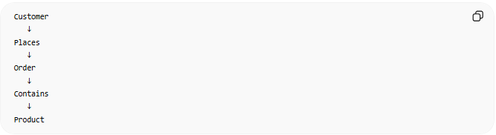
Customer
↓
Places
↓
Order
↓
Contains
↓
Product
Entities:
- Customer
- Order
- Product

⚠️ Entity vs Attribute
# Source: AI Source: Provided by: [Data Path: Persons Table -> ID Column: 1, Name_En Column: Motasem Essam] -> From: [ChatGPT] on [6/10/2026]
Entity
Customer
Represents a thing.
Attribute
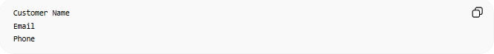
Customer Name
Email
Phone
Represents information about that thing.
Example
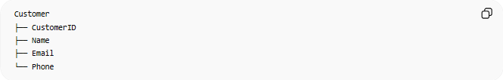
Customer
├── CustomerID
├── Name
├── Email
└── Phone
- Customer = Entity
- Name, Email, Phone = Attributes

🧠 Simple Analogy
# Source: AI Source: Provided by: [Data Path: Persons Table -> ID Column: 1, Name_En Column: Motasem Essam] -> From: [ChatGPT] on [6/10/2026]
Think of a database as a company filing cabinet.
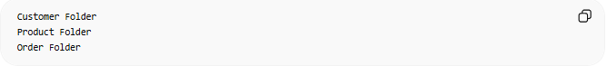
Customer Folder
Product Folder
Order Folder
Each folder represents an Entity.
The documents inside each folder represent the data stored about that entity.

🧭 Summary
# Source: AI Source: Provided by: [Data Path: Persons Table -> ID Column: 1, Name_En Column: Motasem Essam] -> From: [ChatGPT] on [6/10/2026]
An Entity is a real-world object, person, place, event, or concept that a database stores information about. In database design, entities typically become tables and form the foundation of a data model.

